Image | 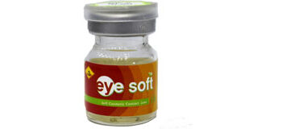
Brand | RAYBAN
Model Name
Price
PRODUCT DETAILS

